**HORAS FEITAS NO SKILLBUILD 2024**

**NOME:** DESIRÉE CONSTANTINO DE ALMEIDA BARBOZA

**EMAIL INSTITUCIONAL ETEC**: [desiree.barboza@etec.sp.gov.br](mailto:desiree.barboza@etec.sp.gov.br)

**TURMA:** 3° DS AMS

**HORAS TOTAIS:** 20 horas

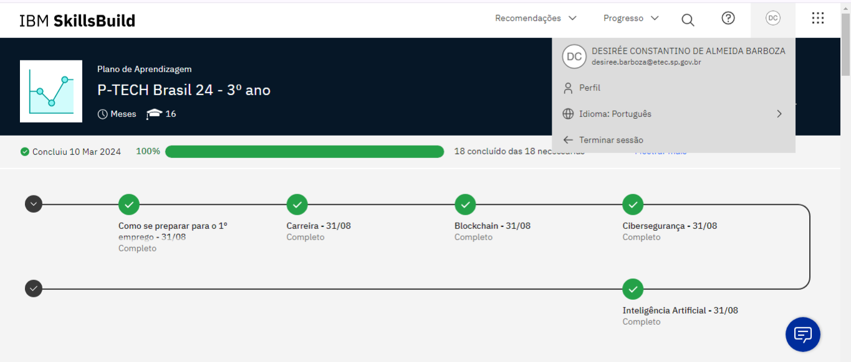

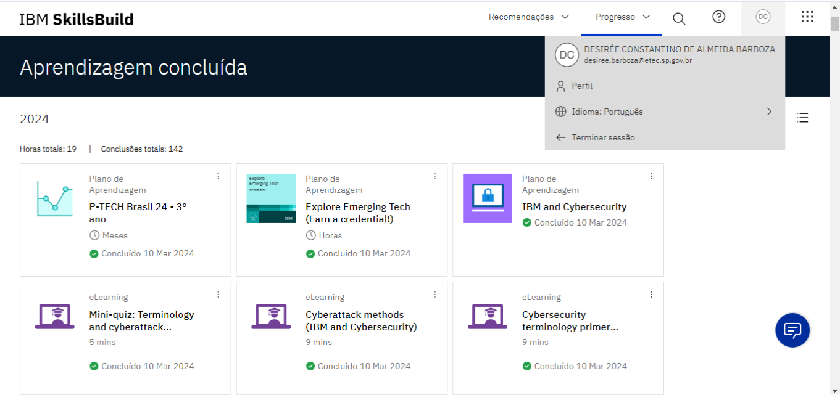

**Como se preparar para o 1º emprego - 31/08**

**Duração Total:** 07 horas e 49 minutos

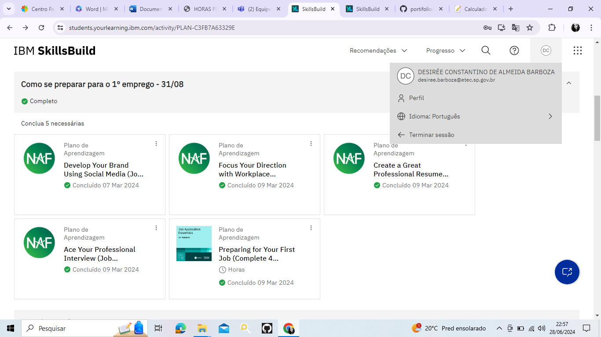**Badge obrigatorio**

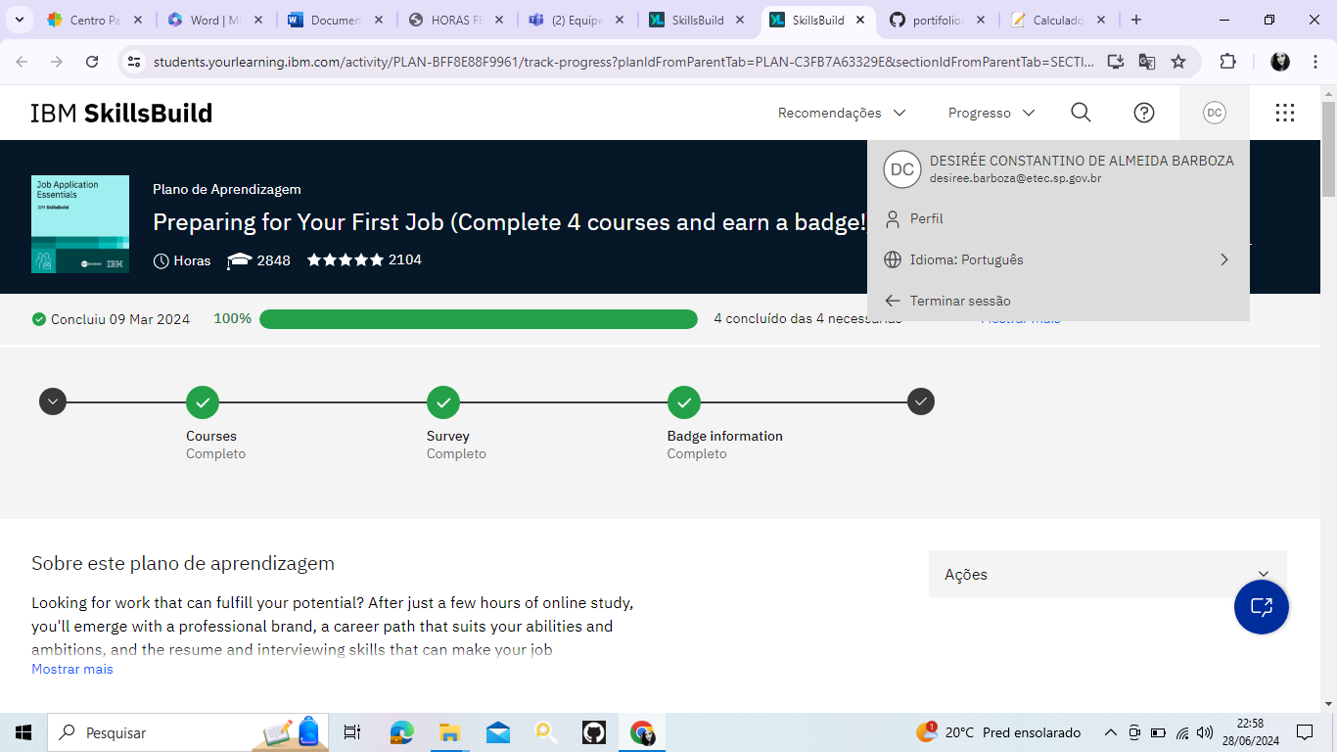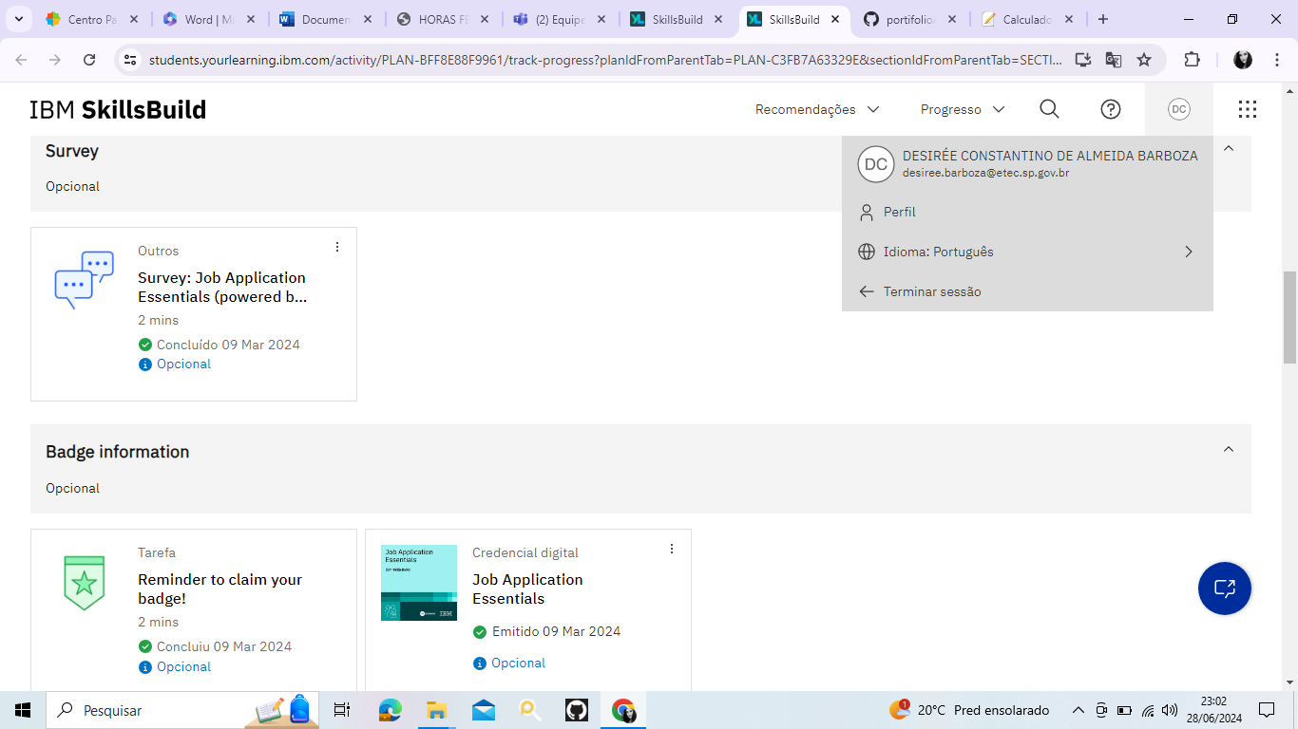

**Carreira - 31/08**

**Duração Total:** 01 hora e 18 minutos

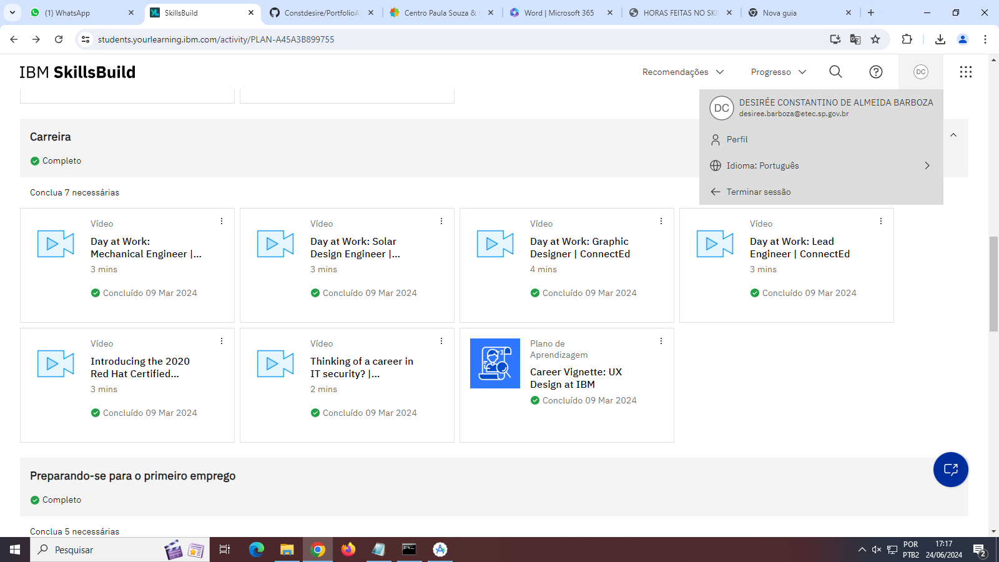

**Cibersegurança - 31/08**

**Duração Total -** 6 horas

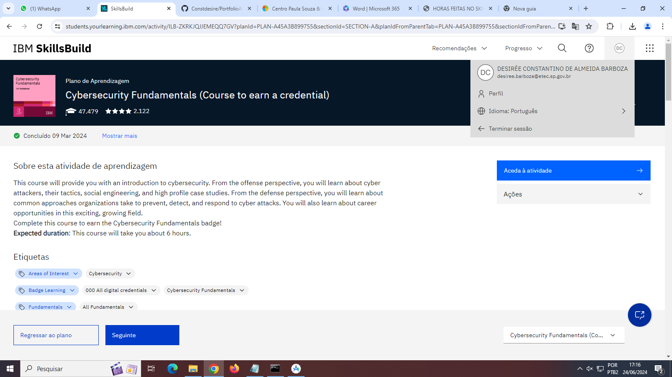

**Blockchain - 31/08**

**35 minutos**

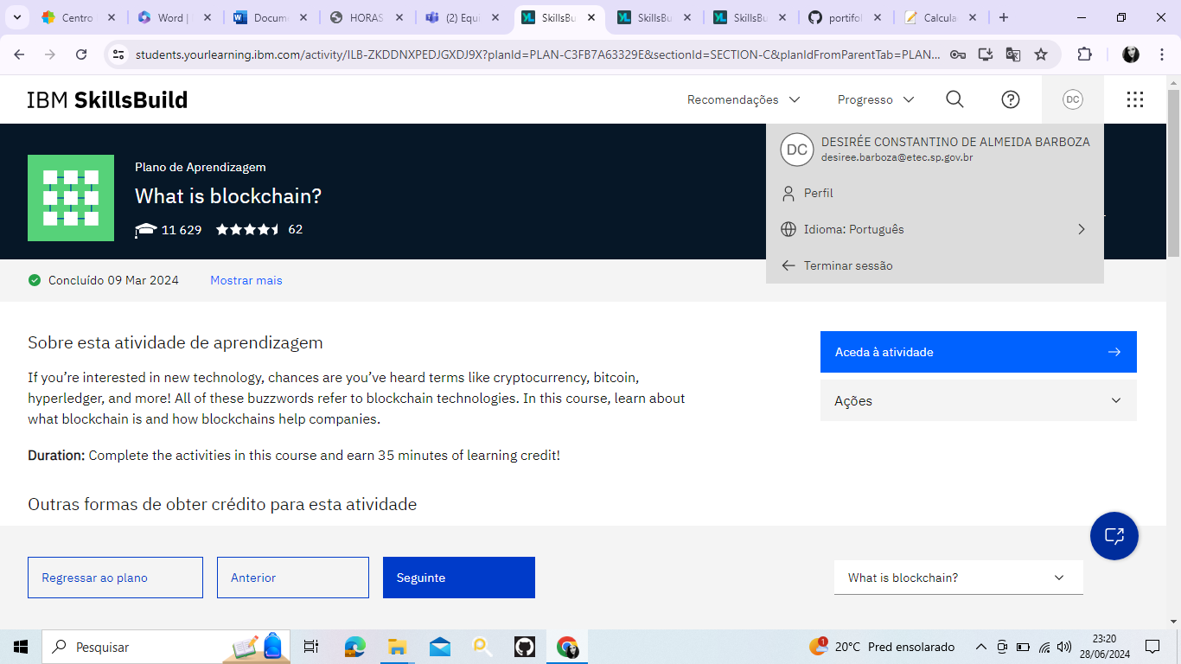

**35 minutos**

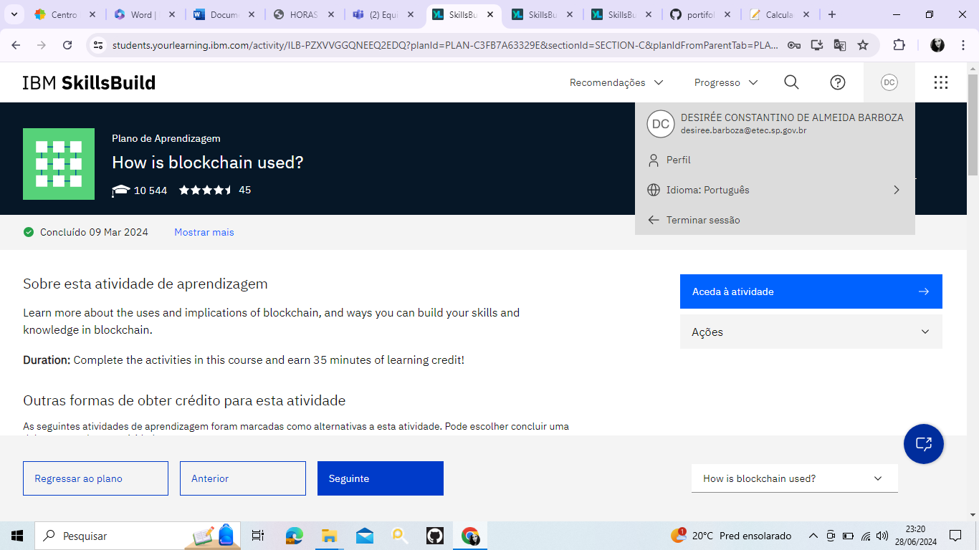  
**Credencial obrigatoria**

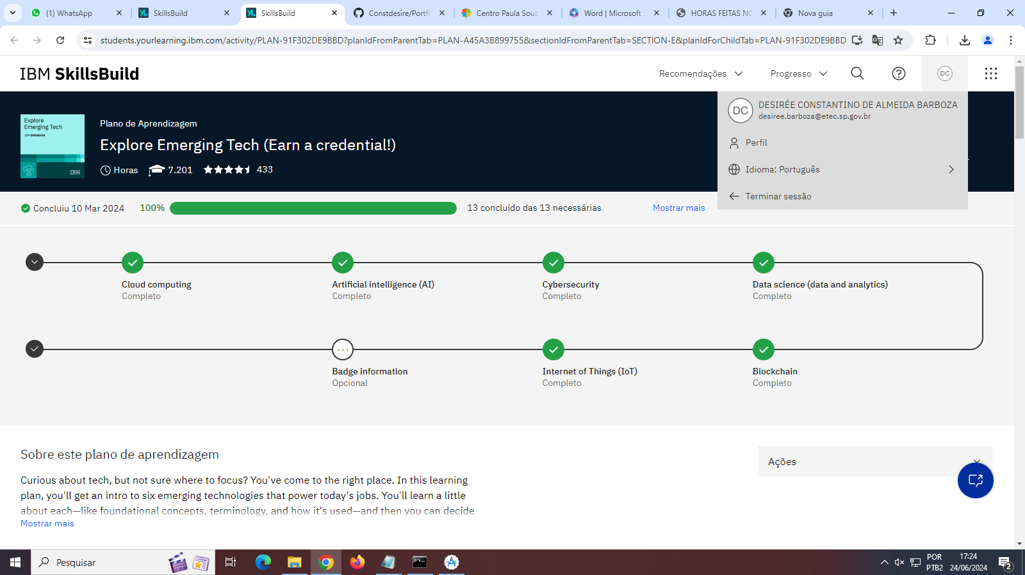

**Inteligência Artificial - 31/08**

**Duração Total:** 01 hora e 25 minutos

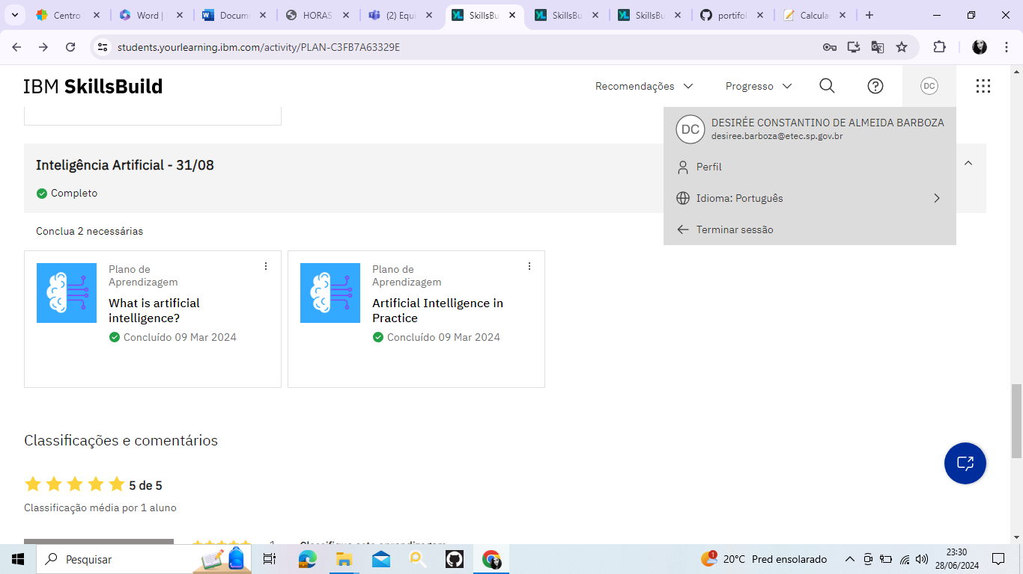

**Cybersecurity**

**Duração Total:** 2 horas

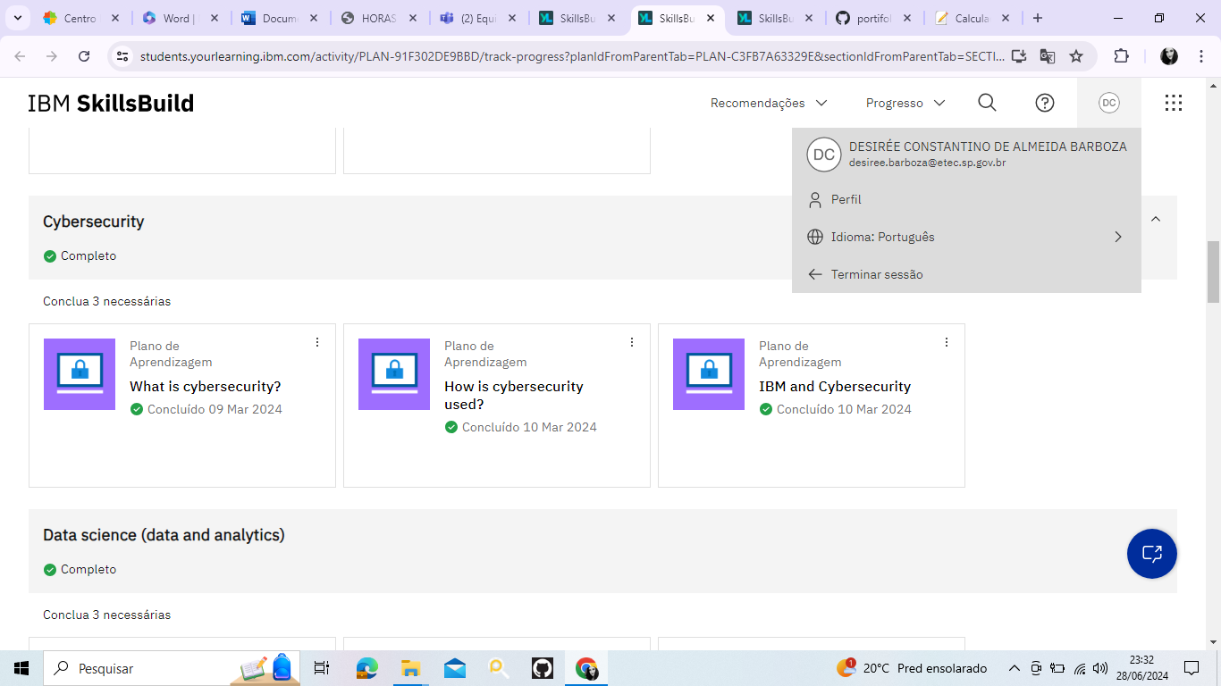

**Internet of Things (IoT)**

**Duração Total:** 10 minutos

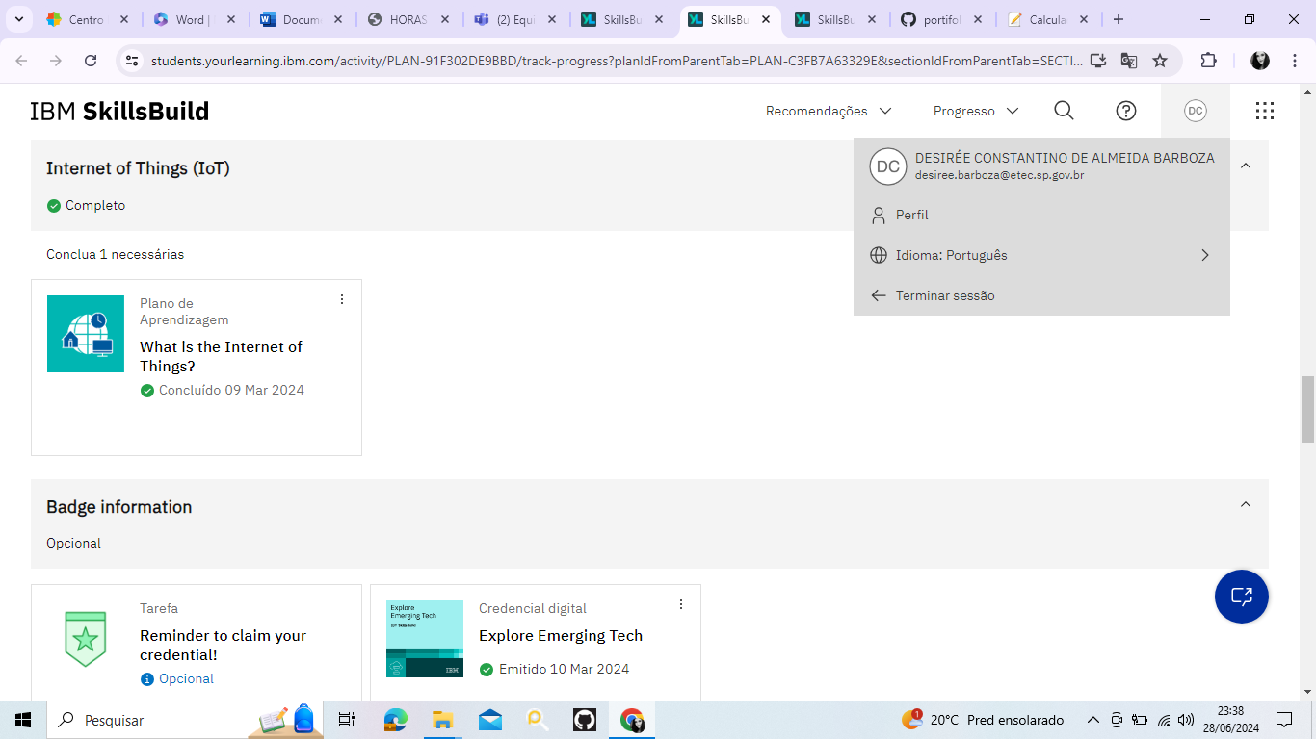

**Credencial:**

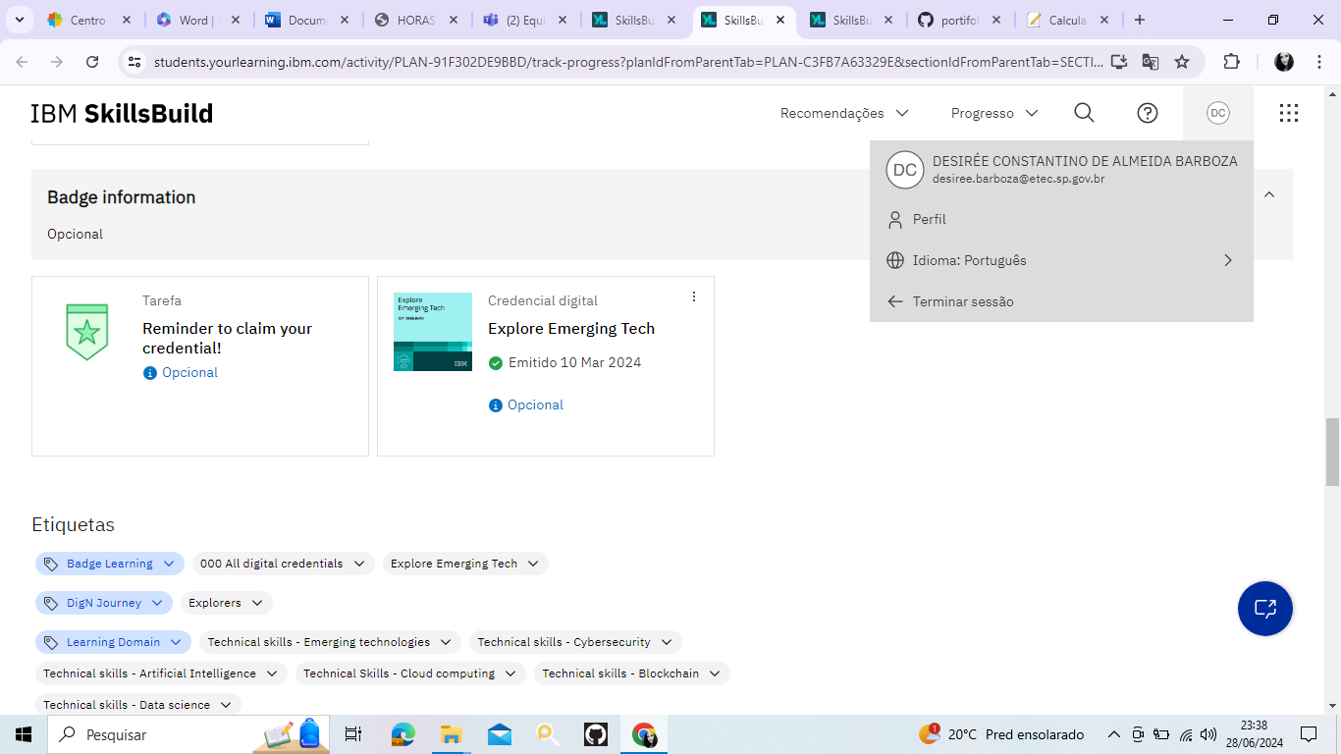

**Inteligência Artificial - 31/08**

**Duração Total:** 01 hora e 25 minutos



**LISTA DETALHADA DAS HORAS FEITAS**

**Como se preparar para o 1º emprego - 31/08**

* Develodp Your Brand Using Social Media (Job Application Essentials) - (1 hora e 45 minutos)
* Focus Your Direction with Workplace Research (Job Application Essentials) - (1 hora e 50 minutos)
* Create a Great Professional Resume (Job Application Essentials) - (1 hora e 55 minutos)
* Ace Your Professional Interview (Job Application Essentials) - (2 horas e 15 minutos)
* Survey: Job Application Essentials (powered by IBM and NAF) - (2 minutos)
* Reminder to claim your badge! - (2 minutos)

**Carreira - 31/08**

* Day at Work: Lead Engineer | ConnectEd - (3 minutos)
* Day at Work: Mechanical Engineer | ConnectEd - (3 minutos)
* Day at Work: Solar Design Engineer | ConnectEd - (3 minutos)
* Day at Work: Graphic Designer | ConnectEd - (4 minutos)
* Introducing the 2020 Red Hat Certified Professional of the Year | Red Hat - (3 minutos)
* Thinking of a career in IT security? | Jobsite.co.uk - (2 minutos)
* Career Vignette: UX Design at IBM - (1 hora)

**Blockchain - 31/08**

* What is blockchain? - (35 minutos)
* How is blockchain used? - (35 minutos)

**Explore Emerging Tech (Earn a credential!)**

**Artificial intelligence (AI)**

* + What is artificial intelligence? - (45 minutos)
  + Artificial Intelligence in Practice - (40 minutos)

**Cybersecurity**

* + What is cybersecurity? - (60 minutos)
  + How is cybersecurity used? - (30 minutos)
  + IBM and Cybersecurity - (30 minutos)

**Interner of Things (IoT)**

* + What is the Internet of Things? - (10 minutos)

**Cibersegurança - 31/08**

* Cybersecurity Fundamentals (Course to earn a credential) - (6 horas)

**Inteligência Artificial - 31/08**

* + What is artificial intelligence? - (45 minutos)
  + Artificial Intelligence in Practice - (40 minutos)